**TRY TABATA:** *AN EXPLOSIVE AND EFFICIENT WORKOUT*

Countless fitness trends have come and gone over the years. Each one promises to help you slim down, tone up, and achieve your fitness goals. Everyone has a different goal in mind when they commit to a fitness plan, and with hard work and dedication most exercise programs will produce results. But what happens if you can’t carve out 60 minutes a day to get your sweat on or you find it hard to stick to a specific fitness plan? Whether you need a quick burn or want to shake up your routine, Tabata training will deliver.

*History of Tabata*

Tabata is a form of high-intensity interval training, more commonly known as HIIT. It was invented by Dr. Izumi Tabata in 1996. Tabata, along with a team of researchers from the National Institute of Fitness and Sports in Tokyo, was hired by the head coach of the Japanese speed skating team to assess the efficacy of their workout program.

During his research, Tabata divided the athletes into two groups and gave each group a different workout plan. Group A worked out with moderate intensity for 60 minutes, five days a week. Group B worked out at a high-intensity level four days a week for only 4 minutes and 20 seconds. Both groups were monitored over a six-week period. At the end of the study, they compared the VO2 max (maximal oxygen uptake) of the athletes in both groups and discovered the high-intensity training performed by Group B had a greater impact on both their aerobic and anaerobic systems. It was concluded that working out in four-minute high-intensity intervals was more beneficial than working out for 60 minutes at a moderate pace.

[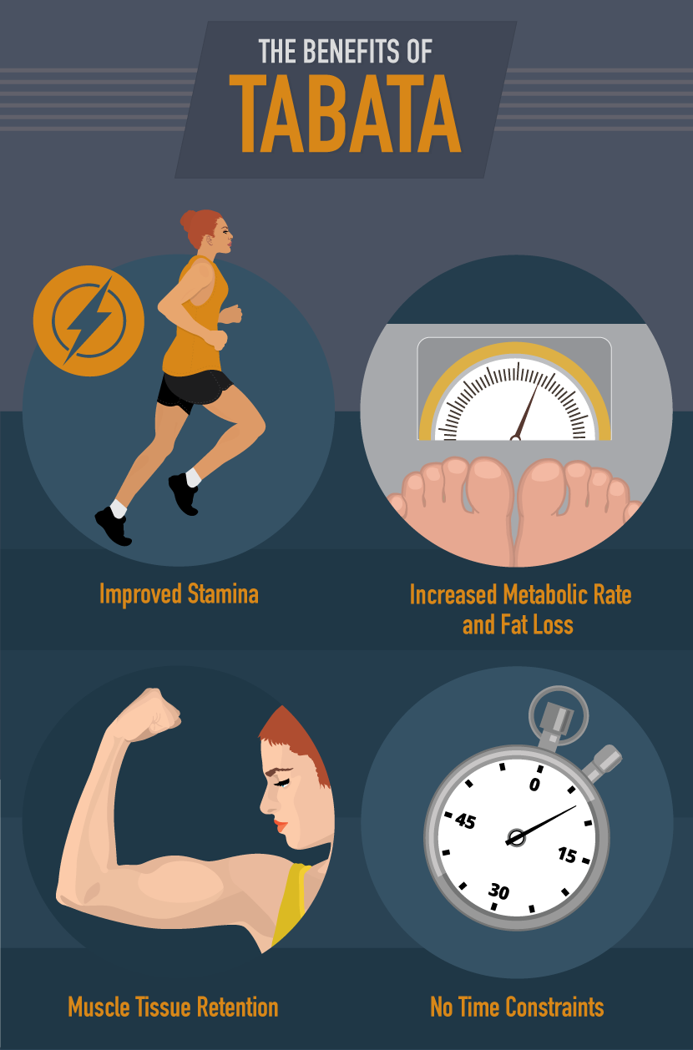](http://www.ereplacementparts.com/blog/the-benefits-of-tabata-workouts/)

*Benefits of Tabata*

**Improved Stamina:** Tabata improves your aerobic and anaerobic threshold. Your aerobic capacity is a measurement of your maximum oxygen uptake during exercise. Your body requires more oxygen when you work out. The rate at which your muscles and tissue are able to absorb oxygen is known as your VO2 max. Most people have a VO2 max between 30 and 60 ml/kg/min. The higher your VO2 max, the more potential you have for aerobic endurance. As you do Tabata training, your VO2 max will improve, along with your stamina.

Anaerobic capacity refers to the maximum amount of energy your body can produce without oxygen. By increasing your anaerobic capacity, you can exert yourself at a maximum effort for a longer period of time. An easy way to measure improvements in your anaerobic capacity is to time yourself while sprinting at 100 percent effort. Record your time and distance. After six weeks of Tabata training, revisit this challenge. You will be amazed at how much farther you can run at maximum effort.

**Increased Metabolic Rate and Fat Loss:** High-intensity interval training increases our metabolic rate by almost 15 times the basal metabolic rate. Your basal metabolic rate is the amount of energy your body uses naturally at rest. Not only are you burning an average of 15 calories a minute, but the increased demand Tabata puts on your body will increase your BMR and torch fat for hours after your workout.

**Muscle Tissue Retention:** If you want to improve your cardiovascular fitness but are concerned about losing hard-earned muscle, Tabata training is for you. The stress placed on your muscle tissue during Tabata sends signals to you body that more muscle tissue is needed and the ratio of lean body mass to fat will increase. If you choose full-body workouts that use more muscle mass, you could actually end up increasing your muscle tissue.

**No Time Constraints:** No time to workout? Can’t get to the gym? These excuses won’t fly when it comes to Tabata training. All you need are four minutes and a pair of sneakers to complete this workout.

*How to do Tabata*

Tabata is a 4-minute workout that consists of eight timed intervals. Each interval is broken down into 20 seconds of all-out exercise followed by 10 seconds of rest. Tabata training is going to mentally and physically push you to your limit. If you are doing this workout correctly, you should feel completely exhausted and find it nearly impossible to finish the final interval.

People often use this form of workout to improve their cardiovascular fitness, but Tabata training is versatile and can also be use to improve weight training and core strength. Beginners should concentrate on cardio, such as running, cycling, and rowing, or bodyweight exercises. Whatever your focus, to get the most out of your workout, it is important you choose exercises that engage a large number of muscles.

[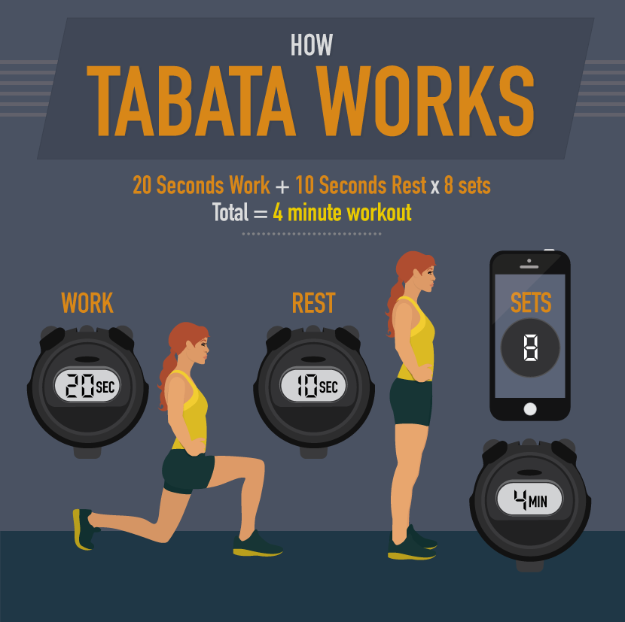](http://www.ereplacementparts.com/blog/the-benefits-of-tabata-workouts/)

*Tabata Warm-Up*

It’s recommended that you do a 5-minute, full-body dynamic warmup before you attempt your first set of Tabata. A dynamic warm-up consists of a series of movements that will engage the muscles you are going to use in your workout. This warm-up will increase your body temperature and range of motion and activate your nervous system. When done properly a dynamic warm-up can improve your performance.

Mix and match these exercises to create a 5-minute dynamic warm-up. Make sure you choose exercises that engage the muscle groups you plan to work out.

* Walking lunges
* Jumping Jacks
* Arm Circles
* High Knees
* Side Bends
* Front Leg Swing
* Push-Ups
* Burpees
* Butt Kicks
* Side Shuffles

*Tabata Workouts*

If you’re new to fitness or are short on time, do one set of Tabata exercises two to three times a week. To get the most out of your workout, it is important to give your body time to rest. Leave a day or two between workouts for your muscles to recover. Once you’re ready to get started, all you will need for most of these exercises is a stopwatch (we use the timer on our phone) and lots of motivation. There are endless options for exercises you can use in your Tabata workout. I have listed below a few for you to choose from based on your fitness level and goals.

[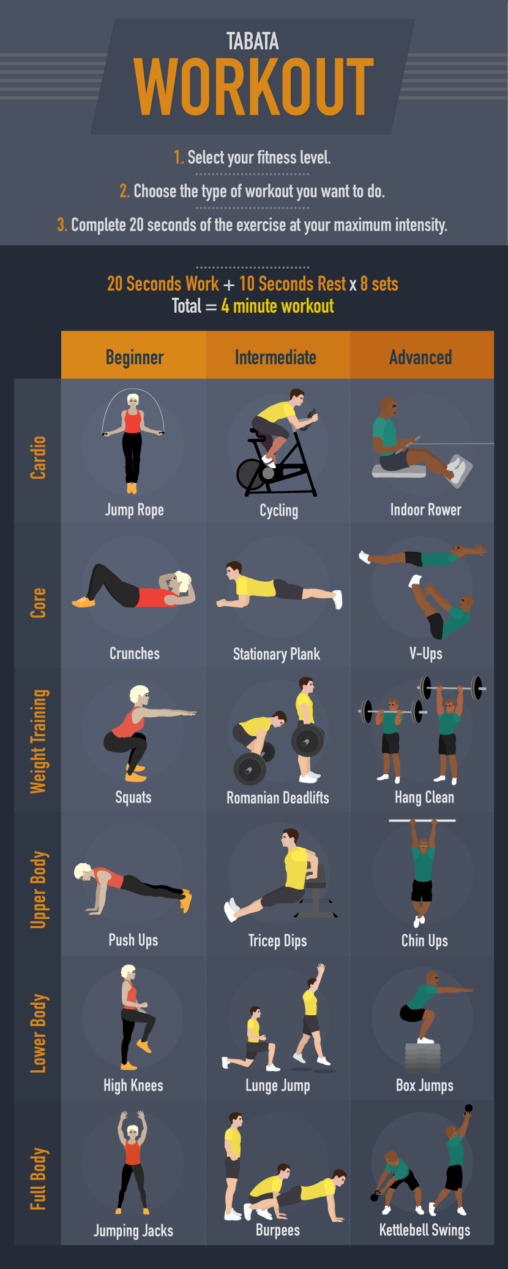](http://www.ereplacementparts.com/blog/the-benefits-of-tabata-workouts/)

*Dangers and Cautions*

Tabata doesn’t involve many risks; however, due to its high intensity, I don’t recommend it for heart patients or people with high blood pressure. This type of interval training rapidly increases your heart rate, so it is recommended that you consult your doctor before adding Tabata to your workout regime.

There is also a risk of injury when you are performing any exercise; however, this risk can increase when you increase intensity and speed. Make sure you are comfortable performing the exercises and can maintain proper form at a moderate pace before incorporating them into your Tabata routine. If you have questions about form or technique, seek out a professional trainer for advice and assistance.

[Original Article](http://www.ereplacementparts.com/blog/the-benefits-of-tabata-workouts/) by [eReplacementParts’ Lifestyle Blog](http://www.ereplacementparts.com/blog/)

Written by [Ashley Aucoin](http://www.ereplacementparts.com/blog/author/ashley-aucoin/)