Staying Fit on a Tropical Vacation
Maintain Your Fitness Amidst All-Inclusive Food and Drinks

There’s no better way to beat the winter blues than to grab your sunscreen and passport and head somewhere tropical. The only problem is, when you’re relaxing on the beach with a piña colada in one hand and a great book in the other, your fitness goals are the last thing on your mind. Here are some simple ways you can stay fit on your next tropical holiday.

Skinny Celebrations

With endless delicious drinks a sip away, you might be tempted to consume more calories than usual on sugary sodas and juices. While the fun tropical beverages may taste great, they will wreak havoc on your diet and waistline. Let yourself indulge on the first day and enjoy the specialty drinks the bar has to offer but stick to these healthier choices the rest of the week.

- Learn the word for diet: Ask one of the local bartenders to teach you the name of your favorite diet soda. Then order this drink to avoid the added sugar and calories.
- Fruit and Fizz: If you aren’t a fan of diet soda, ask for your drink to be mixed with seltzer or soda water. Toss in some fresh fruit or citrus slices to give your cocktail some added flavor.
- Light Beer: Most resorts will carry a variety of local and imported beer. Ask to see the menu and pick out a low-cal brew to cool off with.
- Channel Your Inner Bond, James Bond: Most martinis are low in calories, so if you can’t find a diet or low-calorie mixer, have the bartender shake-up your favorite martini.

Get Involved

While most resorts have gyms on-site, the thought of taking up precious packing space with sneakers and workout gear is unnerving. Even if you opt for extra sundresses and shorts, there's no need to fret. You can still get a great workout at your resort or on your cruise ship just by taking part in the daily activities.

Water Polo

While the bathing caps might look silly, the health benefits of water polo are nothing to scoff at. Did you know that playing 1 hour of water polo can burn up to 700 calories? That’s roughly five Cuba Libres! The object of the game is simple. Two teams compete for possession of a ball and to try to score by throwing it into their opponent’s net. Watch out though! If you have possession, you have to swim quickly, because the other team will try and wrestle the ball away from you!

Pro Tip: Swap out the bikini for a full piece in a more aggressive game of water polo. Things can get a bit aggressive and the only thing you should be worried about losing is the game!

Dance Classes

Just like in Dirty Dancing, your resort will offer fun dance classes on the beach and by the pool. One hour of shaking your hips to Shakira and J-Lo will help you tone your core and legs while torching up to 400 calories per hour.

Aqua Aerobics

Don’t be a spectator on the pool deck–get in the water and try an aquasize class. These classes are perfect for all fitness levels and abilities. If you really want to challenge yourself, head for the deep end of the pool and feel the burn in your legs as you work to keep yourself afloat. A standard aquafit class can burn upwards of 300 calories an hour. Not bad for splashing around to energizing music!

Snorkeling

If you love the ocean and all the beauty that lives below, grab a snorkel and venture out to the reefs and sandbars. Swimming around and spying on the tropical fish is fun and fitness-friendly. This adventurous activity can burn over 600 calories an hour–as long as you don’t eat the bread you bring to attract the fish.

Beach Volleyball

You don’t need to be in a Top Gun montage to join in on a beach volleyball game. Even if you are new to the sport, the lateral movements and jumping in the sand alone will be a great core and leg workout. Add in the bumps, sets, and spikes and your shoulders and arms will be feeling the burn too. Spend an hour on the courts and sweat out up to 500 calories.

Beach Workouts

Take your vacation up a notch with this full-body, calorie-blasting, beach workout.

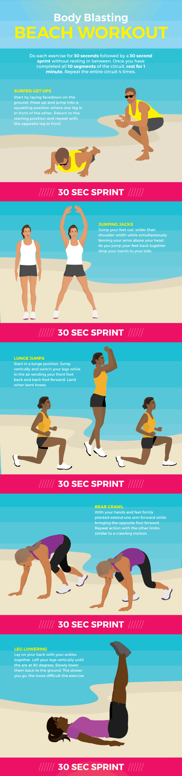
Barefoot Running

Embrace the beautiful tropical morning and head to the beach for a barefoot run. The loose, dry sand causes your feet to sink and your stabilizing muscles to work harder than they normally would when running on a treadmill or sidewalk. You can burn up to 80 extra calories per mile running on sand! If you are new to running, I suggest sticking to the harder wet sand and slowly progressing to dryer sand as your body becomes more accustomed to the terrain. The beach is a beautiful place to run–just make sure to keep your eyes open for sharp sticks and shells.

Heat Protection

If you’re heading outside to do a workout on your tropical vacation and aren’t used to the climate, make sure you keep these six things in mind:

- Stay Hydrated: Always have a water bottle nearby when you are exercising in hot weather. Adding the element of heat to your workout means your body will lose more water than it would in your regular gym routine. To avoid dehydration and keep your performance up during your workout, drink a minimum of one cup of water for every 15 minutes of exercise. Be sure to replace lost fluids after your workout too. Experts recommend drinking at least two cups of water for every pound you lost during your workout.
- Decrease Intensity: If you aren’t used to working out in the heat and humidity, you will notice that they can really slow you down. Scale back the intensity of your workouts to accommodate these new elements. If you normally run four miles, aim for three. Gradually add more to your workout as your body acclimatizes.
- Dress Appropriately: Opt for loose-fitting, light-colored clothing. The loose clothes will improve air circulation to your skin and keep you cool while the light colors won’t absorb the heat as much as dark ones. Toss on a ballcap and sunglasses for added protection.
- Sunblock: Even if you are just heading out into the sun for a quick workout, you can still get a burn and sun damage. Make sure you choose a waterproof sunscreen, otherwise if you sweat a lot the lotion can end up in your eyes and cause a burning discomfort.
- Before 11 and After 3: Know when the sun will be at its hottest and avoid working out during those hours. Typically the hottest times of the day are between 11am and 3pm. If you must workout at this time, drink extra water and find some shade, or jump in the pool.
- Know Your Limits: If you start to feel dizzy, light-headed, extreme fatigue, or nausea, it’s time to stop. Listen to your body when you are working out in a new climate. If you don’t feel right, stop, drink some water, and find an air-conditioned room.

Tips for the Buffet

The buffet–the best part of any vacation (in my opinion). This is the place where dreams are made and fitness goals can be quickly forgotten. Avoid falling victim to the buffet by following these simple guidelines.

Original Article by Fix’s Lifestyle Blog

Written by Ashley Aucoin

