[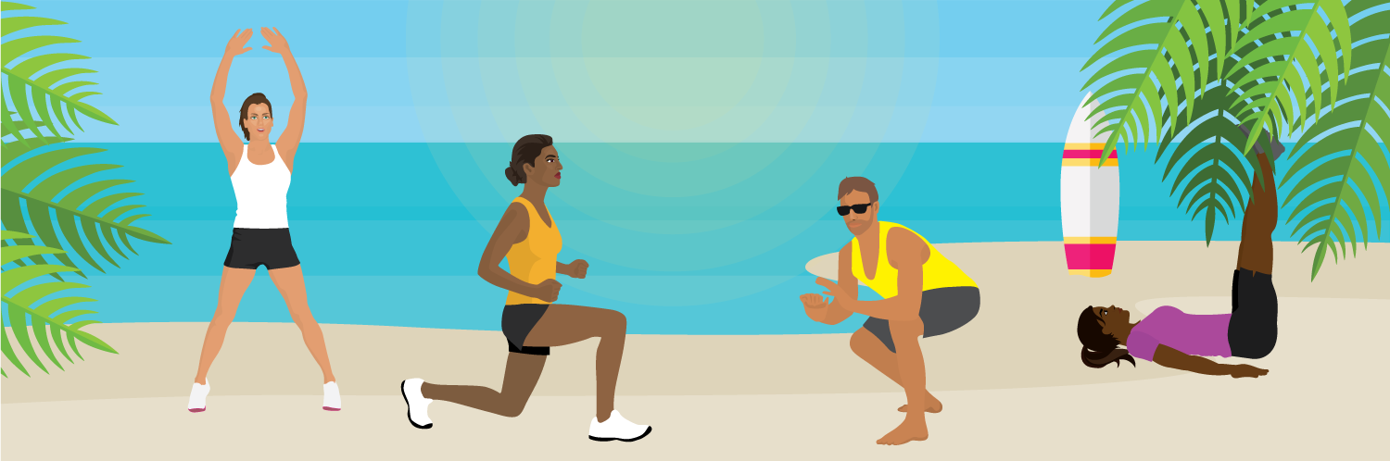](https://www.fix.com/blog/keeping-fit-on-resort-vacation/)

**Staying Fit on a Tropical Vacation**

*Maintain Your Fitness Amidst All-Inclusive Food and Drinks*

There’s no better way to beat the winter blues than to grab your sunscreen and passport and head somewhere tropical. The only problem is, when you’re relaxing on the beach with a piña colada in one hand and a great book in the other, your fitness goals are the last thing on your mind. Here are some simple ways you can stay fit on your next tropical holiday.

Tips for the Buffet

The buffet–the best part of any vacation (in my opinion). This is the place where dreams are made and fitness goals can be quickly forgotten. Avoid falling victim to the buffet by following these simple guidelines.

[](https://www.fix.com/blog/keeping-fit-on-resort-vacation/)

1. Take Stock: As soon as you arrive at the buffet, walk around and see all the options you have. Once you are aware of your meal choices you can make a final decision on what to eat. This will reduce the temptation to keep going back to the buffet to see if there was something you missed or forgot to try.
2. Plate Size: The large plates not only let you take more food, but they also skew your perception of portion size. To avoid overeating, grab smaller plates and bowls.
3. Grab a Tray: Having a tray to pile your plates on gives you the ability to take stock of your food choices. When people feel restricted in their options, they tend to go for the items they really want, versus what they should be consuming (dessert wins over the garden salad when you only have room for one plate). The tray also allows you to do a quick scan of your plates. It’s going to be very obvious if you’re missing extra greens!
4. Hide Out: Once you have your meal, sit as far away from the buffet as possible. By not having the food in sight you won’t be as tempted to get up for seconds or crave more. We tend to eat more of what is in our line of sight so if you can’t avoid viewing the buffet, sit closer to a healthy section.
5. Dine and Dash: Schedule an activity for immediately after your meal. Knowing you have to work out will make you more cautious about your food choices and portion sizes.

Vacations are for relaxing and having fun, so don’t be too hard on yourself for missing a couple of workouts. Follow our maintenance tips and enjoy your holiday. The gym will be waiting for you when you come home.

[Original Article](https://www.fix.com/blog/keeping-fit-on-resort-vacation/) by [Fix’s Lifestyle Blog](https://www.fix.com/blog/)

Written by [Ashley Aucoin](https://www.fix.com/blog/authors/ashley-aucoin/)