**Playing Sports as an Adult**

*Getting Back Into Team Activities*

Start Slowly

When you go back to an old sport, start out slowly. Injury is one of the biggest risks to people starting a new sport or re-engaging in one they haven't played in years. Doing too much too fast is almost assuredly going to result in an injury, so start off slowly and don't try to tackle it all at once. If you're getting back into a team sport, consider adding a few days of another activity, such as running or yoga, to your schedule to help your body get back into shape. Stretching and yoga help your muscles limber up, increase flexibility, and help decrease the likelihood of injury. Give your body time to recover and adapt to the new routine.

As you get more involved in the sport, keep your expectations in check. Remember that record you set in high school? The five-minute mile you ran in college? Don't compete with your younger self. There are a lot of ways in which adult athletes perform better than they did in their youth, but it takes time and focus to develop those skills.

If it's been a long time since you played the sport or you've opted for trying something totally new, consider taking a class or finding a trainer to help you get the most out of your re-entry into sports. Always talk to your doctor before embarking on any new fitness regime.

[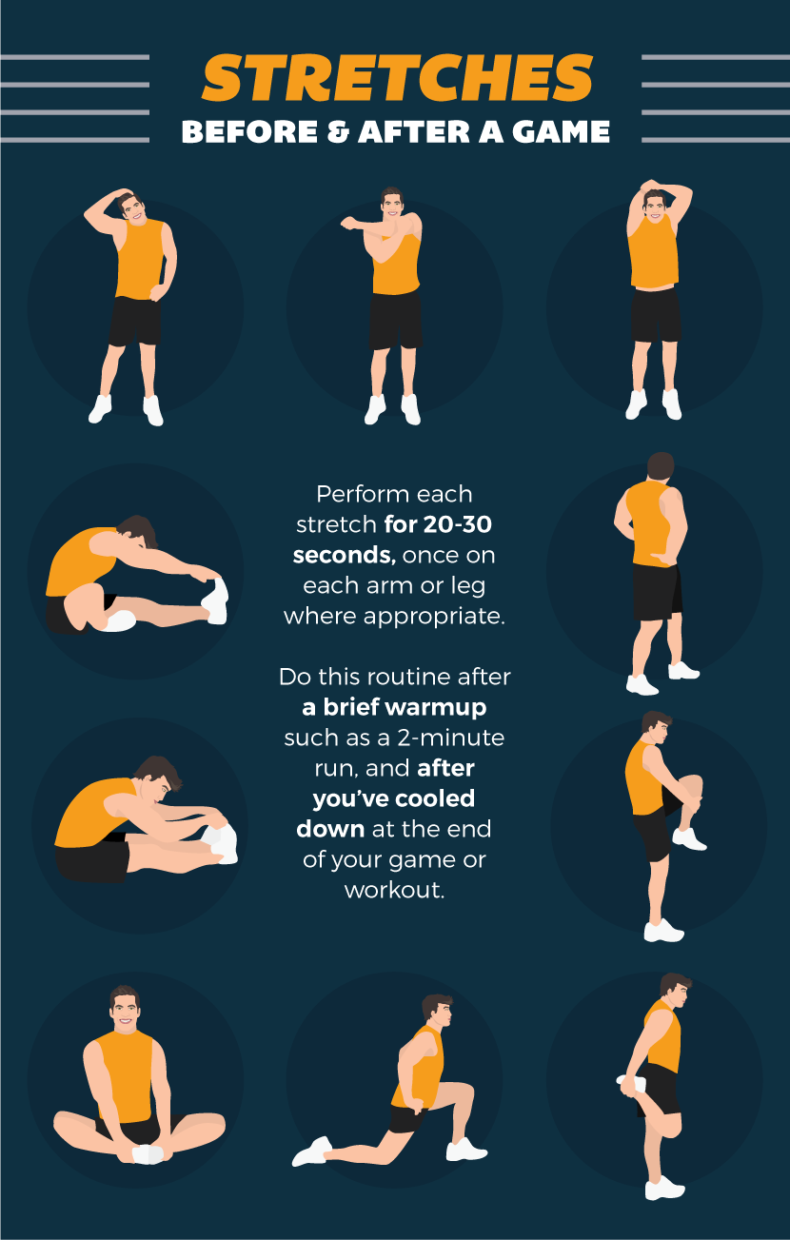](http://www.partselect.com/blog/getting-back-into-sports/)

Team Sports

When you're just rejoining a sport and haven't been especially active for a while, look for recreational leagues that are based on having fun rather than on pure competition. Sports should be fun, yet the stress of having to be great right out of the gate can be off-putting for some people. Enjoying the activity will give you time to improve your fitness level; you can always move up to a more competitive league when you're ready for a bigger challenge.

If you're the kind of person who prefers to just get out for fun, look for a group that's like-minded. Many towns have recreation departments that host adult sports leagues. Some smaller towns host weekly sporting events for adults at the local high school; in larger urban centers, check out the Y or a gym to see if they offer adult sports.

Some sports are easier to rejoin than others: pick-up basketball games are ubiquitous, as are masters swim leagues and running clubs. For more complex sports such as hockey or fencing, finding a team can be a little more challenging, especially if you live in a rural area. Don't be afraid to look a bit further afield, and if you can't find a group to join, consider creating your own!

[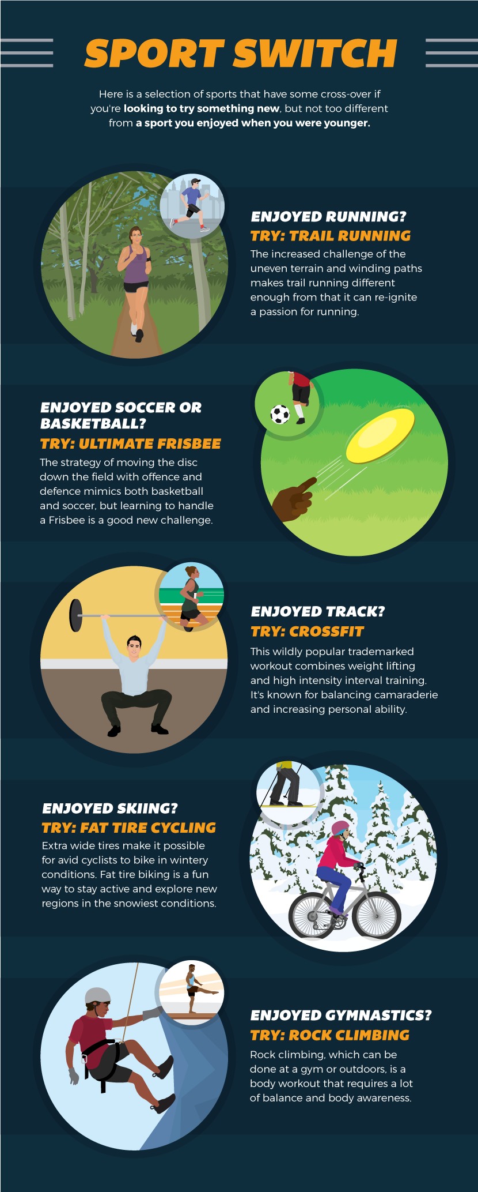](http://www.partselect.com/blog/getting-back-into-sports/)

Individual Sports

Solo sports such as skiing, running, or weightlifting are often the easiest to pick back up, because you don't have to find a team or a league. The downside to these sports is that they can be lonely, especially if you're restarting and it's harder than you remembered. Staying engaged and committed can be difficult if you're always on your own. If this is the case for you, there are often clubs you can join or gyms where you'll meet a workout partner.

Gear

If you've been out of a sport for a while, the amount of gear that seems necessary for participating can be daunting, even if it's just running: the right shoes, socks, shorts, and shirt, not to mention the extra gear that goes with your specific sport! Depending on the sport, though, it's often unnecessary to invest in all the gear, never mind the fanciest, when you're first restarting. Wait a few months or a year to see how much you enjoy the activity before buying nicer stuff. Some sports such as fencing, hockey, and skiing do require a few unique items. See if you can buy some of the pricier items used from a sports shop, or attend a local gear swap. S ome stores will rent expensive equipment such as skis and bikes on a day-to-day basis. This can be an economical way to test your excitement about participating in a sport before you really commit. The one thing to never skimp on is any safety gear that's used in your sport. This can be a big expense, but it's always worth the cost.

Fitness for adults, whether through organized team sports, specialized group exercise classes, or a personal challenge encouraged by a fitness tracker, is trending nationwide. So, whether it's been a few years or a few decades since you last participated in a sport, there's no need to wait any longer to get back in the game.

[Original article](http://www.partselect.com/blog/getting-back-into-sports/) by [PartSelect Blog](http://www.partselect.com/blog/)

Written by Alison Hudson