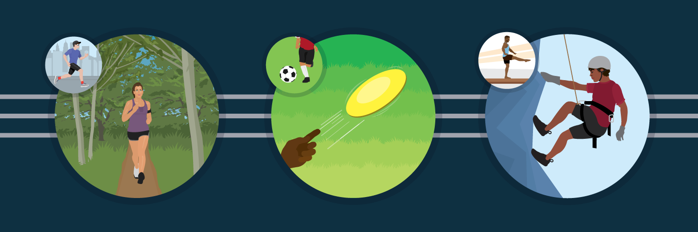
Playing Sports as an Adult
Getting Back Into Team Activities

Do you ever find yourself thinking about that sport you gave up back in high school or college? Maybe you went a different route when there wasn't enough time to keep up with the rigorous practice schedule, or you weren't interested in playing at a higher level of competition. No matter what the reason was for leaving the sport behind, it can be difficult to rejoin it as an adult. If you're looking to get back into the game but aren't sure where to start or how to play safely as an adult, here are some ways to get started.

Set a Goal

Before you jump back into a sport you once played, consider the following question: Why are you doing this? It may seem basic, something barely worth considering. However, having a goal can inform how you approach the sport you're getting back into, especially the tenacity with which you do so. If your goal isn't to set a personal best, do you really need to be pushing quite that hard on the court? Young people often have high expectations of themselves when playing sports, which can impact an adult's perception of the activity when they try to get back into it. Winning and constantly improving may not be reasonable goals for an adult and can make it hard to enjoy re-entering a sport, because these expectations are often out of line with realistic goals. For some people, the tenacity with which they practiced and played as a child make it difficult to enjoy a sport as an adult, because their body now has different limitations. Setting a goal helps keep things in perspective when a sport gets frustrating.

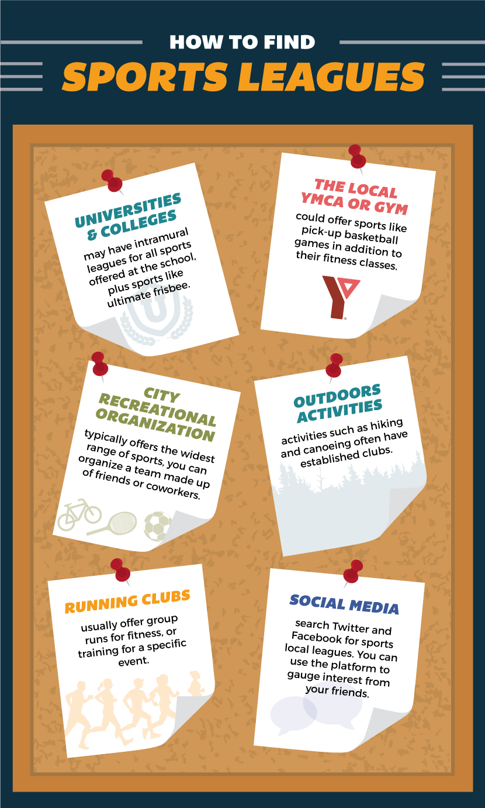
Original article by PartSelect Blog

Written by Alison Hudson

